**Lady Denman Cup Competition 2021**

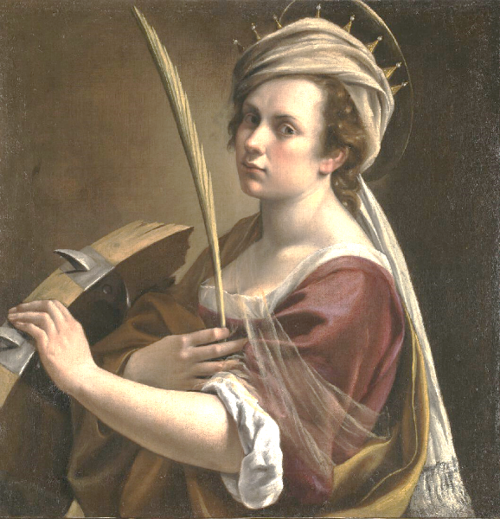***“Let me show you what a woman can do!”***

**Schedule**

The NFWI is pleased to announce that the Lady Denman Cup Competition 2021 will be held in partnership with the National Gallery. Using no more than 500 words, WI members are invited to submit a piece of writing, fact or fiction, in any style (story, poem etc.) based on this painting by Artemisia Gentileschi.

* Entrants must submit 4 copies of their entry, typed if possible, on A4 paper to theFederation Administrator no later than **Thursday 29th July**. Any entries sent directly to the NFWI Unit without being approved by the federation, cannot be entered and will be returned to the entrant.
* Each entry must include a total word count; entries with over 500 words will not be accepted and will be returned to the Federation Secretary.
* The name of the entrant, WI and Federation to be written on the first copy only; entrant’s details must not be written on the remaining copies.
* Entries must be accompanied by a completed Individual Entry Form. Please contact the Federation Administrator for a form or download from My WI.
* All entries will be judged in the first instance at federation level and up to three entries from each federation can go forward to the national competition.
* All entries at national level will receive a critique by the Judge.

**All forms relating to the competition can be downloaded from My WI/Make, create & do.**

**Please send your entries to:**

**SFWI Federation Office, The Cornerstone, Common Road, Stafford**

**ST16 3EQ by Thursday 29th July 2021.**

##### Prizes

Book tokens will be given as prizes: 1st prize, book tokens to the value of £75; 2nd prize book tokens to the value of £50 and 3rd prize book tokens to the value of £30. The winner/winning federation will be presented with the Lady Denman Cup.