SFWI Education and Public Affairs Sub-Committee July 2021

ACWW is dependent solely on Membership Fees and ‘Coins for Friendship’
Please donate as generously as you are able, to support rural women in developing countries.
Many thanks
Jenny Crump
SFWI ACWW Representative

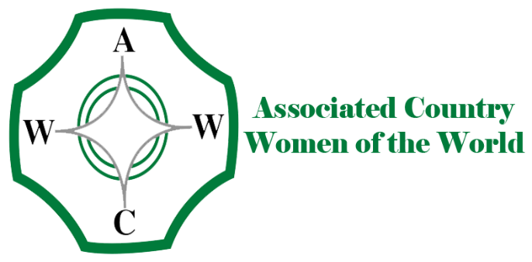

SFWI Education and Public Affairs Sub-Committee ACWW July 2021
Dear Treasurer

Please bank the cash received and send a cheque for the same amount, made payable to ACWW, not SFWI, together with this slip no later than Thursday 4th November 2021 to:

SFWI Federation Office, The Cornerstone, Common Road, Stafford ST16 3EQ

Thank you.

WI …………………………………………………………. Total amount enclosed £ …………….

