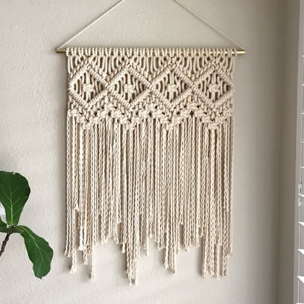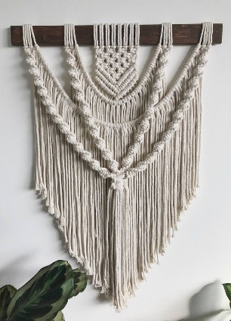

Macramé Wall Hanging

Create a beautiful wall hanging using the art of Macramé – a crafting technique that uses cord and knots to create various textiles – size to be no larger than A3

# SFWI CAD COMMITTEE Craft Competition April 2022

Total Payment………….

NAME OF WI ………………………………………………………

Payment Method

Email Address……………………………………………………… …………………………….

Name and address: ………………………………………………. Date: …...…………………

………………………………………………………………………

Create a Macramé Wall Hanging of your choice but to a size no larger than A3 (297 x 420 mm; 11.7 x 16.5 ins) which excludes any hanging cord.

Entries must have been completed within the last two years and be the member’s own work. Entries are limited to one per member and the entry fee is £3.50 per entry.

Please attach your name and WI somewhere discreetly on the finished item.

All entries will be displayed at our “It’s Christmas!” event in November. Please arrange for your item to be collected at the end of the meeting.

Please complete the form below and return with your cheque and finished item to:

SFWI Federation Office, The Cornerstone, Common Road, Stafford ST16 3EQ or alternatively email admin@sfwi.org and pay by bank transfer to The Staffordshire County Federation of Womens Institutes, Sort Code: 30-84-26 (Lloyds Bank),Account Number: 41005868. Use reference RP/Surname/WI. Or pay by credit / debit card on Tuesdays or Thursdays by calling 01785 223838. Please state date payment was made. Entry form, finished item and payment to reach us no later than Thursday 8th September 2022.

**NOT LATER THAN THURSDAY 25th February 2021.**

Craft, Art and Design Sub Committee April 2022

**Rosemary Palmer Trophy**