**£5 pp per session— see below**

**Crochet & Knitting - All Abilities**

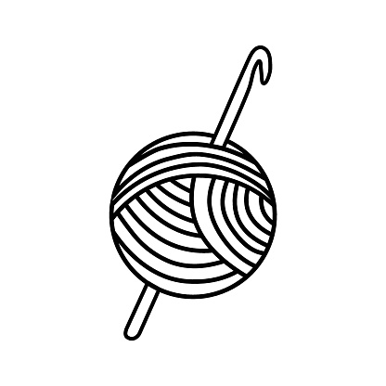

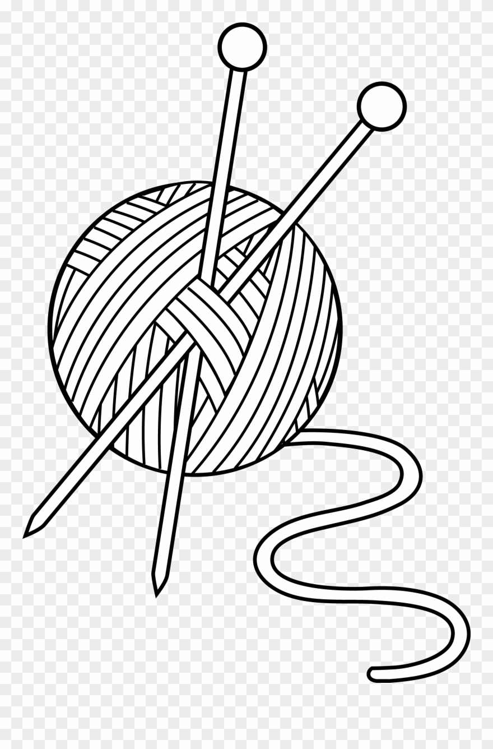

Come to Cornerstone on Saturday 23rd July 2022.

10.30 am – 12.30 pm

CAD sub-committee members will be available to assist whether you are just starting or more advanced

Yarn and crochet hooks available, or bring along your project

# SFWI CAD COMMITTEE CRAFT & CHAT SESSIONS May 2022

Total Payment………….

NAME OF WI ………………………………………………………

Payment Method

Email Address……………………………………………………… …………………………….

Name and address: ………………………………………………. Date: …...…………………

………………………………………………………………………

**Register by emailing the completed application form below to** [**admin@sfwi.org**](mailto:admin@sfwi.org)**. no later than Monday 18th July 2022. Alternatively post to Federation Office. — only a small number of places available so book early to avoid disappointment. No tickets will be issued.**

**Payment**—£5 pp per session. **Full Payment on booking**.

Please send payment no later than **18th July 2022** – Payment by cheque payable to SFWI to The Cornerstone, Common Road, Stafford ST16 3EQ or alternatively pay by credit/debit card on Tuesdays or Thursdays or by bank transfer to The Staffordshire County Federation of Womens Institutes, Sort Code 30-84-26 (Lloyds Bank), Account 41005868. Use ref: CC/WI/Name.