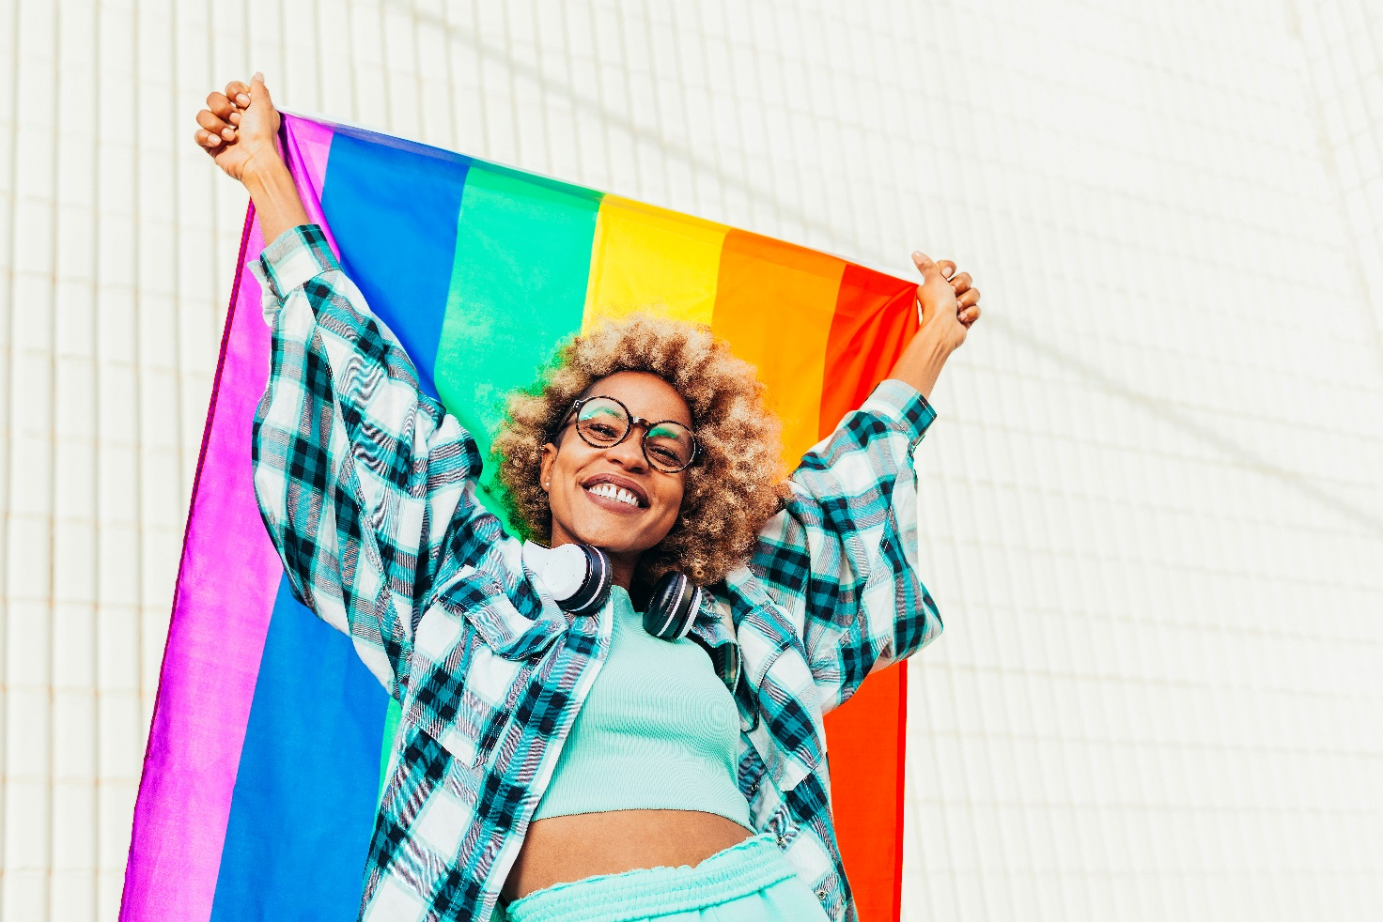
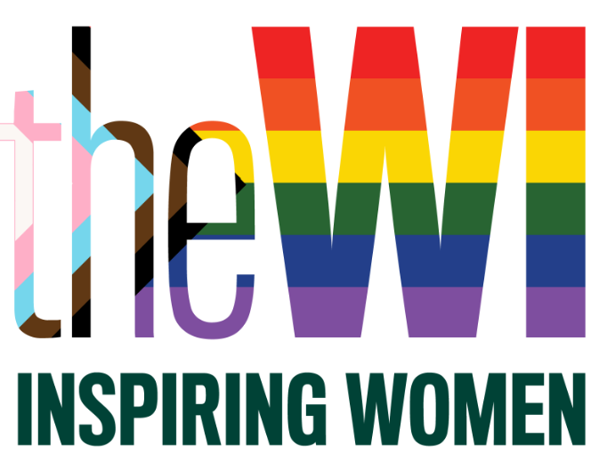

INSPIRING WOMEN…
to celebrate and embrace diversity
The WI was founded on democratic ideals over 100 years ago and this commitment to equality is still central to our ethos today. The WI is an inclusive, supportive and progressive organisation for all women with a diverse membership of around 190,000 members. The WI is open to all women. It welcomes and celebrates a diverse cross-section of women, offering a space where they can be themselves surrounded by other supportive women. We are committed to ensuring all members are treated fairly and equally whatever their background or individual circumstances, with equal access to all opportunities on a national and local level.

The WI is proud to be celebrating the LGBTQ+ History Month 2023 #BehindTheLens. Celebrating LGBTQ+ peoples’ contributions to cinema and film from behind the lens and at a time when LGBTQ+ lives are in the media, we encourage you to look ‘Behind the Lens’ and listen to LGBTQ+ peoples’ lived experiences, starting with our partnership organisation – Hundred Heroines…

‘Skin Deep’ with Paola Paredes
Tuesday 7 February 2023 (7.30pm – 8.30pm)
Join Paola Paredes from Hundred Heroines to hear about her recent exhibition Skin Deep. This fabulous exhibition symbolically reconstructed personal stories through ‘interactive portraiture by tearing aside perceived stereotypes, and showing a community that is ethnically, economically, generationally and emotionally diverse.

“Skin Deep transgresses and questions how we interact with art; its innovative narrative creates a unique, playful and individual experience” Paola.

This event is free of charge and open to WI members only.

Paola Paredes is an Ecuadorian photographer whose work is centred around the experiences of LGBTIQ people, and how they navigate attitudes towards homosexuality in her home country. Through both staged imagery and documentary photography, Paola illustrates personal and complex interactions between sexuality, culture and religion.

Online Course: LGBTIQ+ History Month with Hundred Heroines - Meet Photographer Paola and Explore Her 'Skin Deep' Exhibition (FREE COURSE)

WI Film Club: Beyond the Screen
Thursday 23 February 2023 (6pm)
With so many films now available to us through Netflix, Amazon, Sky (to name just a few!) it can sometimes feel overwhelming scrolling through page after page, trying to find a good film. Why not let us take away that indecisive pressure and join us at the WI Film Club – Beyond the Screen!

Starting in February, and to acknowledge it being LGBTQ+ History Month, we are inviting members to watch The Imitation Game and join the new, free WI Film Club: Beyond the Screen on Thursday 23 February 2023 at 6pm to discuss the story in a safe, secure and unthreatening online session.

The Imitation Game will be aired on BBC on 2 Feb and will be available on iPlayer shortly after broadcast: BBC One - The Imitation Game. The film is also on Netflix, Sky Cinema and Amazon Prime for those with these subscriptions.

Online Course: WI Film Club - Beyond The Screen

Let’s talk about… LGBTQ+ History Month
Every year people across the UK come together to mark LGBT+ History Month in a celebration of the LGBT+ community and culture. It is also an event that raises awareness of and combats prejudice against, LGBT people and history. The first UK LGBT+ history month in the UK was created in 2005 by Schools Out UK. It is held in February each year to coincide with the 2003 abolition of Section 28.

The WI has collated some free-to-view and low-cost TV, film, museum and written resources that will help you to learn more about, and celebrate, LGBTQ+ history. This resource can be found on My WI

- Show your support for LGBTQ+ month by creating one of these wonderful projects:
  - Macrame Pride Bracelet (attached)
  - My WI | Hanging Rainbow (thewi.org.uk)
  - My WI | Rainbow Pancake Cake (thewi.org.uk)

Powered by Denman, delivered with thanks by…

To find out more about events and courses offered by the WI please visit
www.theWI.org.uk or www.denman.org.uk

