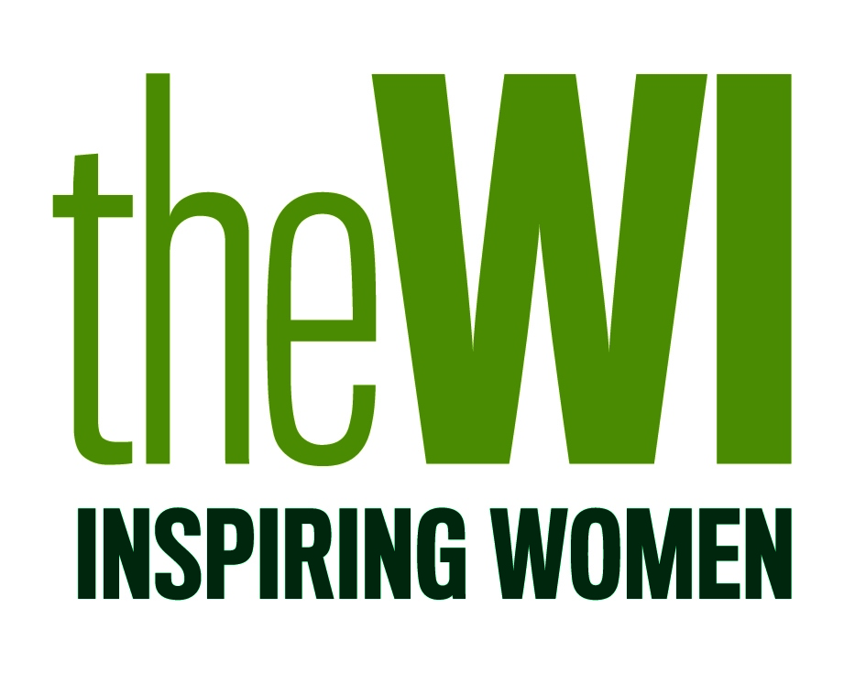
Royal Greeting Cards 2023
Guidelines for Makers

Throughout the Queen Elizabeth's reign and membership of the WI, it was an annual tradition to invite WI members to create a birthday card, which would be sent on behalf of the Board of Trustees and the WI to celebrate Her Majesty's birthday in April.

This year, the NFWI would like to continue this tradition and send a birthday card to our Royal members of the WI; Her Majesty The Queen Consort and Sophie, Countess of Wessex, as well as other female members of the Royal Family which have a long-standing reputation of supporting the work of the WI and campaigns that have been important to our members.

- WI members are invited to create a card(s) which can be sent to a member of the Royal Family, at a time chosen by the NFWI Board of Trustees.

- Members are encouraged to be as creative and imaginative as they wish, using any style or technique, however we would ask that the final design is reflective of the Women’s Institute as an organisation (not an individual WI). We ask that the card includes a title, name of maker, WI and federation either written or printed on the back of the card.

- The finished card must be sent to the NFWI (address below) along with contact details for the maker including email, address, telephone, WI and federation.

- The maker of the chosen card will be informed by email as to who the card has been sent to, why and when.

- Commercial items, such as toppers, stickers or wording, should not be used. Branding or manufacture logo’s must not be visible.

- The final card dimensions should measure no less than 148 x 210mm (A5) and no more than 210 x 297mm (A4).

- Text inside the card must read ‘WI members send their warmest good wishes to you on this very special day’. If the maker choses to leave the inside of the card blank, this text will be entered by the NFWI on their behalf.

- The maker must provide a short-written statement explaining the theory behind their finished piece of work plus a brief bio of themselves. This piece must be written and presented to a high standard worthy of accompanying the finished card.

- The finished card must be sent to the NFWI (address below). If the maker wishes to deliver their work by hand, arrangements for delivery date and time must be prearranged and agreed with the NFWI.

- If selected, the card will be sent to the NFWI Head Office, London to be signed by the NFWI Chair, and photographed before being sent to appropriate Royal Household. The card will be sent along with the written piece detailing the maker (refer to point 8).

- The NFWI will ensure that the card is wrapped and presented to a high standard before sending.

- The NFWI reserves the right to publish images of the chosen card, along with the written statement, on WI social media channels, My WI and in WI Life.

- The finished card will be sent to the appropriate Royal Household on behalf of all WI members, for this reason, the NFWI will take ownership and responsibility of the card.

- Once the card has been sent, the maker nor the NFWI will be able to ask for the card to be returned.

- No financial renumeration will be offered in return for the card, however the NFWI will ensure that the maker is acknowledged for the contribution and that the card is profiled across all our platforms and social media.

Please note, all cards submitted will be held safely by the NFWI until an appropriate time in which a card will be selected and sent, on behalf of the WI, to a chosen member of the Royal Family. We can not guarantee that your card will be used in the immediate future, however, we will ensure you are informed directly should your card be chosen. Once submitted to the NFWI, cards cannot be returned.

Delivery details:
FAO Education & Training Team
NFWI, The Lambourn, Wyndyke Furlong, Abingdon, OX14 1UJ

